**Introduction**

Sleep is the body’s resting period that helps removes toxins and allows the brain to concentrate and respond quicker. The lack of sleep can lead to the development of disorders such as cardiovascular diseases, diabetes, and obesity. Generally, sleep mechanism is a combination of circadian rhythm and homeostasis which work together to control the timing of sleep and regulate sleep intensity. The first three stages of sleep are considered NREM, and this is when the muscles and the brain began to relax and slow down to their lowest levels. The last stage, REM phase, is when the brain goes back to being active and the heartbeat began to rise to a similar level as when the body is awake.

**Method**

The components for this lab consists of an ADXL335 accelerometer, an LCD, and Arduino Uno. In the code, the raw values (x,y, z) from the accelerometer were used to calculate the magnitude and compared to a manually set threshold. A step or movement was counted every time the magnitude exceeded the threshold. The setup was powered by a 9V battery and was taped and put inside a box for protection. A pedometer app and a self-build pedometer were used to track sleep movements for five nights.

**Result**

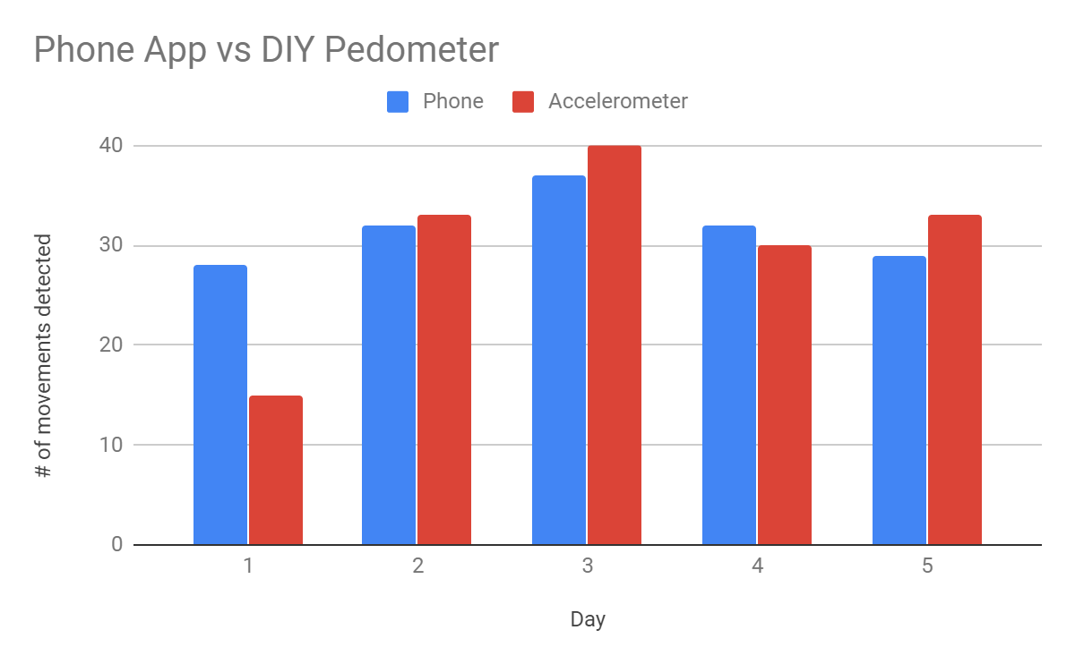

**Discussion**

The main problem with the accelerometer was that it could not detect rapid movements. For the first day, the calibration was not sensitive enough to track sleep movements, and as for the fourth day, the error might arise due to loose wires. With proper calibration, the ADXL335 performed better than the app overall. As such, this setup is a great tool for tracking steps, but it not recommended for tracking sleep activity.

**Code**

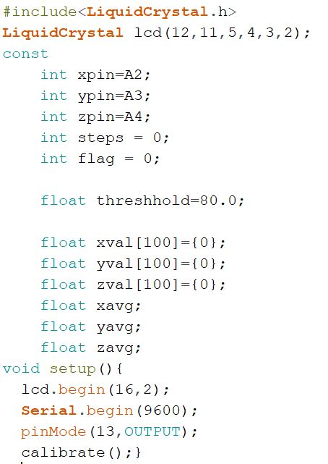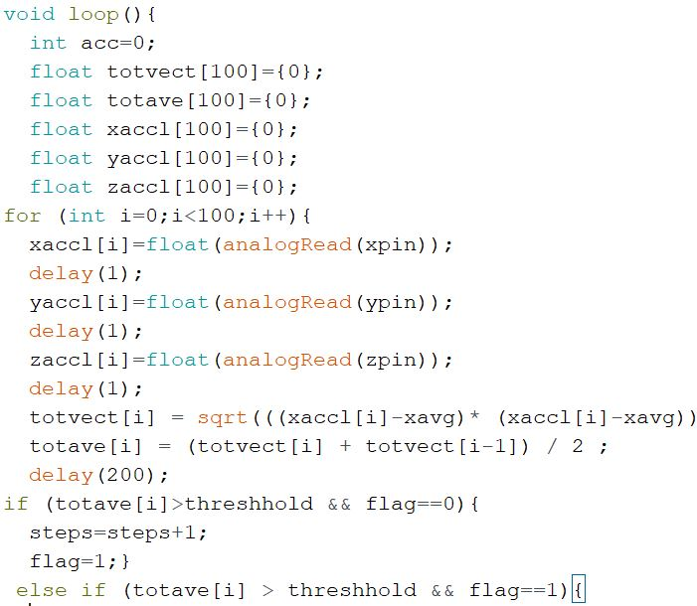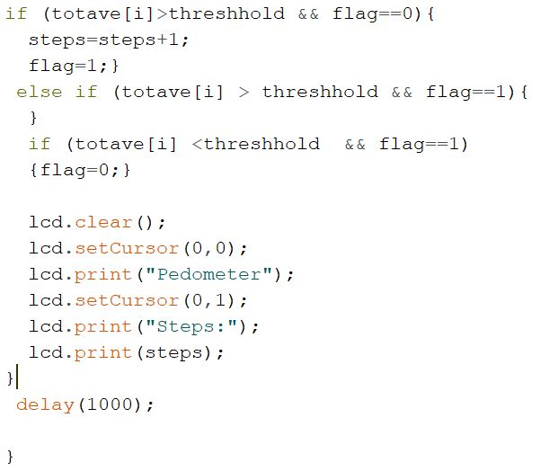

**Source**

Instructables. “Simple, Easy and Cheap DIY Pedometer With Arduino.” *Instructables*,

Instructables,15Oct.2017,https://www.instructables.com/id/Simple-Easy-and-Cheap-DIY-Pedometer-with-Arduino/.